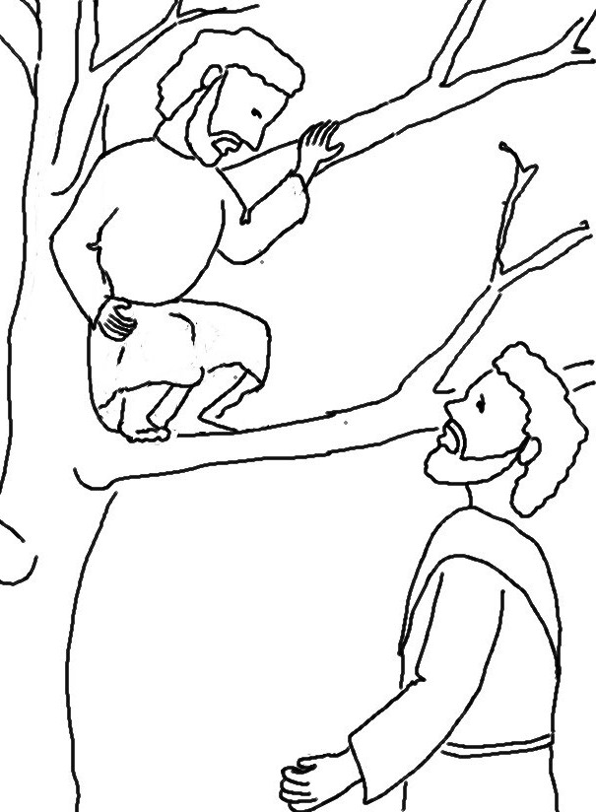

For the Son of Man came to seek and to save the
lost.
Matthew 19:10_{NLT}

